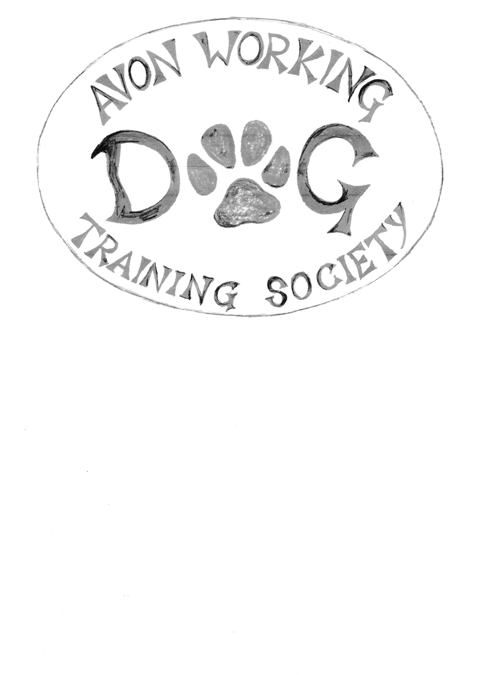

|  |  |
| --- | --- |
| Name |  |
| Address |  |
|  |  |
|  |  |
|  |  |
| Telephone number |  |
| Mobile number |  |
| E mail address |  |
| Name of Dog(s) | Breed |
| Have your dog(s) ever trained in | Yes/ No |
| Protection/bitework? |  |

AVON WORKING DOG TRAINING SOCIETY Membership application

**RATE: £10 PER YEAR (£5 IF JOINING AFTER 1ST JULY)**

Existing members only need to fill one out if details have changed.

I hereby apply for annual membership of Avon Working Dog Training Society.

Signed…………………………………………………………..Date……………………………...

Do you agree for us to store and use this information for club purposes? Yes/No

*(Before signing please make sure you have read and understood our Privacy Policy on back of this form)*

Notes:

1. **Membership** becomes due on 1st February each year. Membership acceptance is subject to committee approval. In order to attend one of our workshops or training days you will need to be a fully paid up member.
2. **Owner’s liability**: - It is a condition of membership that you accept full responsibility for the actions of your dog/s. By signing a membership application to join AWTTS, you agree to this clause and should consider public liability insurance for your protection. Do not bring your dog onto any AWTTS ground if you suspect it may be carrying any kind of infection or if you think it may compromise the safety of other people, animals or property. The training of protection/bitework at AWDTS may only be undertaken by members specifically approved by the committee to do so..

Please return this form to: Caroline O’Hare, AWTTS Treasurer

Email: avonworkingdogs@gmail.com

and pay the subscription via BACS (please state your name clearly in the reference):

Avon Working Dog Training Society

Sort Code: 30 92 13

Account Number: 01532164

If you are unable to pay via BACS please let us know and we will give you details for alternative methods of payments

**Privacy Notice**

* 1. Avon Working Dog Training Society is committed to protecting your personal information and respecting your privacy. We operate in accordance with the General Data Protection Regulation [the GDPR]. The data controller is Avon Working Dog Training Society.
  2. We may update this Privacy Notice from time to time. Please check our website regularly to see any updates or changes to this Notice.

1. **Data Protection Contact**
   1. The contact details for our Secretary for any data protection queries or complaints are as follows: Chris Gamson, who can be contacted on 01793 522917 or cgamson@btinternet.com
2. **Particulars of processing**
   1. We collect information given to us by our members on our membership application form.

3.2 We use this data to provide membership services; to maintain our records and other administrative purposes; to keep members up to date with club related matters, to invite members to participate in dog related events

3.3 We keep a list of current members’ names and addresses in a password protected file and the committee use this in order to carry out activities mentioned in 3.2

3.4 We will never share, sell or rent your data to third parties.

3.5 We may make our membership list available to the Kennel Club if required to do so by them.

3.6 We will keep details of unpaid members for a maximum of six months after renewal is due. If payment has not been made, we will assume they will not be renewing and we will delete their details from our database.

1. **Your rights as a data subject**
   * 1. You can request access to the personal data that we hold about you, you can request rectification and erasure of your data. In order to do this please contact our club Secretary.